To Implement Responsive Web Page and Git History Exploration
The project structure consists of a folder containing two main files: index.html for the webpage content and style.css for styling. The HTML file is modified to include a responsive image using the <img> tag with CSS classes, and the layout is made adaptable to different screen sizes using CSS media queries in style.css. The CSS file is linked to the HTML using the <link> tag inside the <head> section. Version control is managed using Git, where changes are tracked with git add, committed with git commit, and monitored using git status. To explore version history and manage code changes, commands like git log (to view commit history), git diff (to see file differences), git checkout (to revert changes), and git reset (to unstage files or reset to previous commits) are used effectively, demonstrating a complete cycle of responsive design and Git-based project tracking.

Tasks:
- Modify the existing HTML page to include:
  - A responsive image.
  - A layout that adapts to screen size using CSS media queries.
- Add a CSS file (style.css) and link it to the HTML file.
- Track changes using git add, commit, and use git status throughout.
- Use git log, git diff, git checkout, and git reset to demonstrate version control and history exploration.
Programs:
responsive web/
- index.html
- style.css
- kluh.png
- git/ (created after `git init`)

How to create project folder
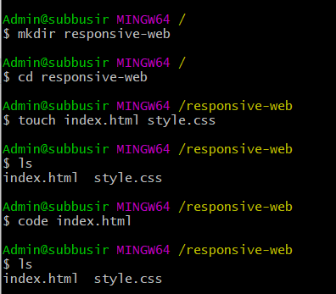
Directly its open VScode
Index.html:

<!DOCTYPE html>
<html lang="en">
<head>
<title>Responsive Web Page</title>
<link rel="stylesheet" href="style.css">
</head>
<body>
<header>
<h1>Welcome to My Responsive Page</h1>
</header>

<section class="about">
<img src="kluh.png">
<p>This page includes a responsive image and adjusts layout using CSS media queries.</p>
</section>
</body>
</html>
style.css
body {
font-family: Arial, sans-serif;
margin: 0;
padding: 0;
}

header {
background-color: #333;
color: white;
padding: 20px;
text-align: center;
}

.about {
padding: 20px;
display: flex;
flex-direction: row;
align-items: center;
gap: 20px;
}

.responsive-img {
width: 100%;
max-width: 400px;
height: auto;
}

/* Media Query: Stack content on small screens */
@media (max-width: 600px) {
.about {
flex-direction: column;
}
}

Output:
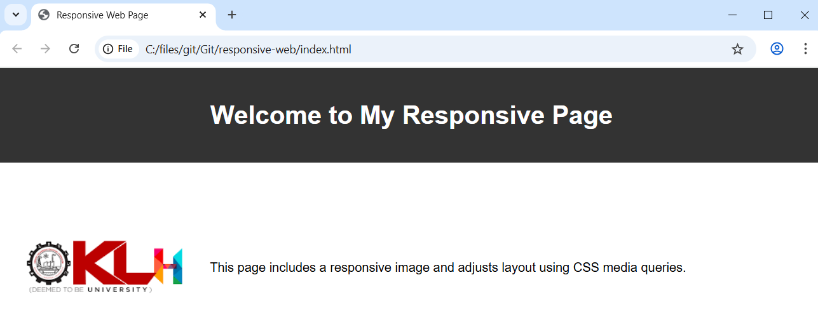

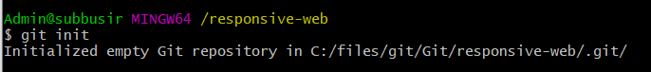
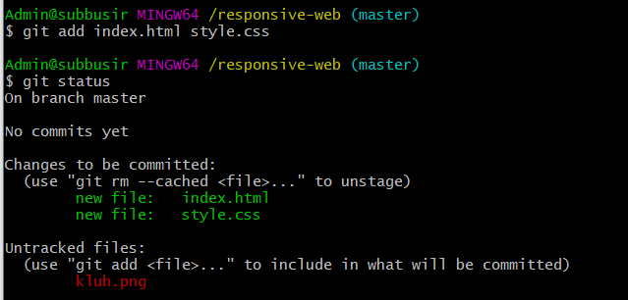

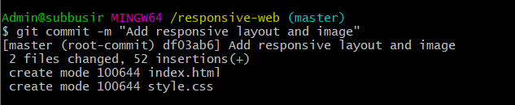
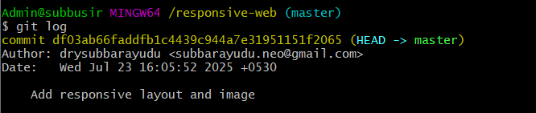
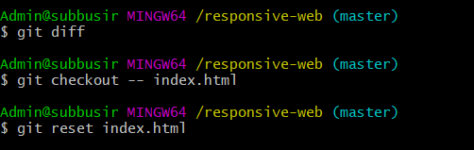
After modification of the program
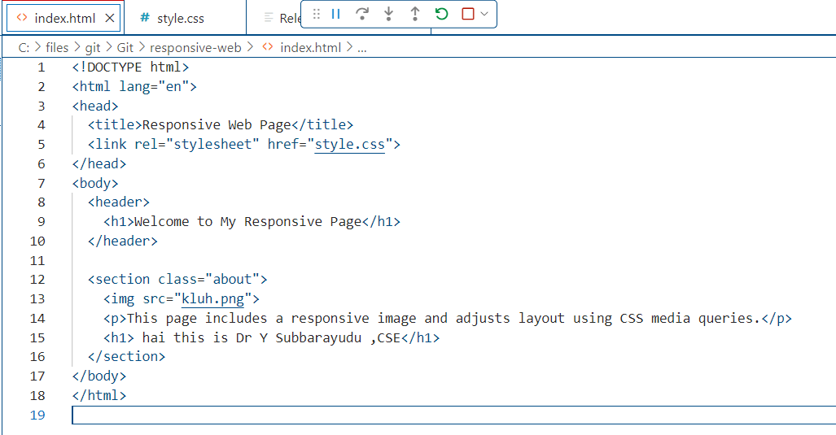
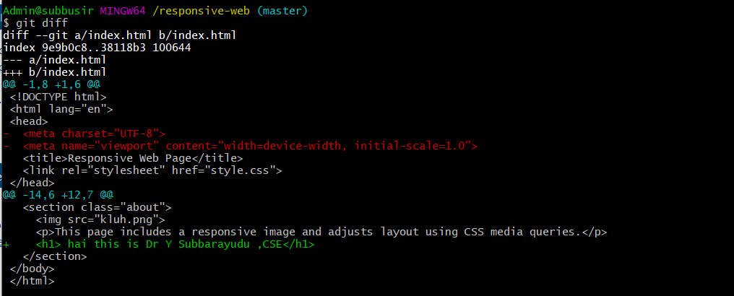


Git to github (push to github)

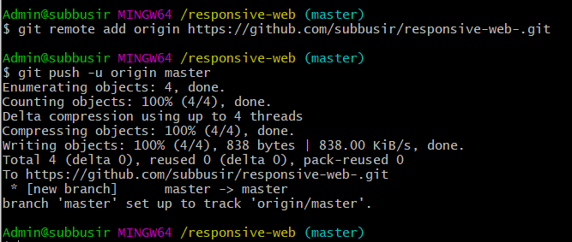

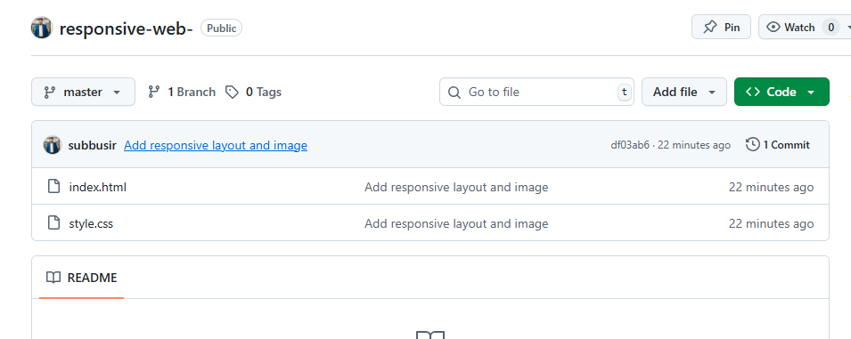

RESULTS:

As a result, the project was successfully executed with a responsive image and a layout that adapts seamlessly to various screen sizes using CSS media queries. The style.css file was properly linked to index.html, and styling changes reflected as expected. All changes were tracked and committed using Git, with git add and git commit confirming successful staging and saving of changes. Commands like git status, git log, git diff, git checkout, and git reset were effectively used to monitor version history, view modifications, revert unwanted changes, and manage staging. The project structure remained organized, and all version control operations were completed without errors, demonstrating a smooth and

